- Click the link:
https://www.ihg.com/redirect?path=hd&brandCode=IC&localeCode=en®ionCode=1&hotelCode=HAKUL&_PMID=99801505&GPC=J79

- Input the check in and check out date and click “View Prices” button.
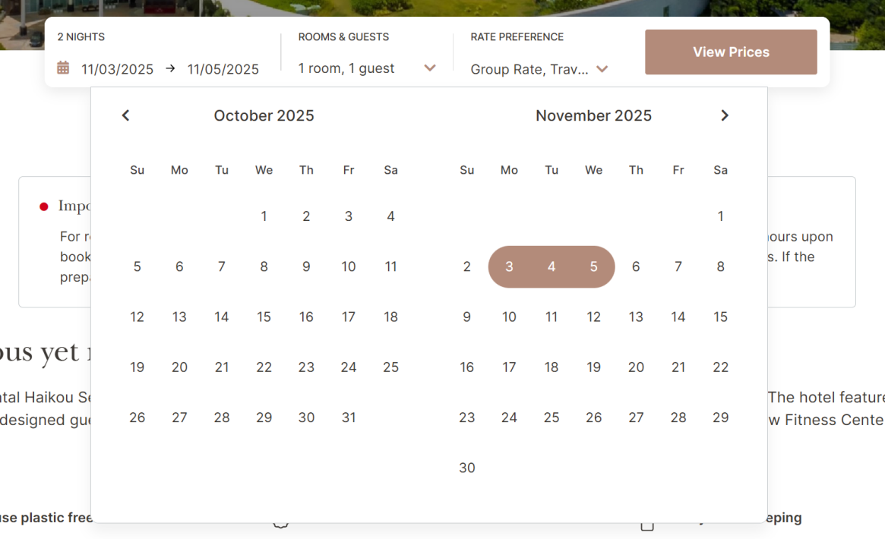

- You can choose the room with “IVSM meeting” group rate.
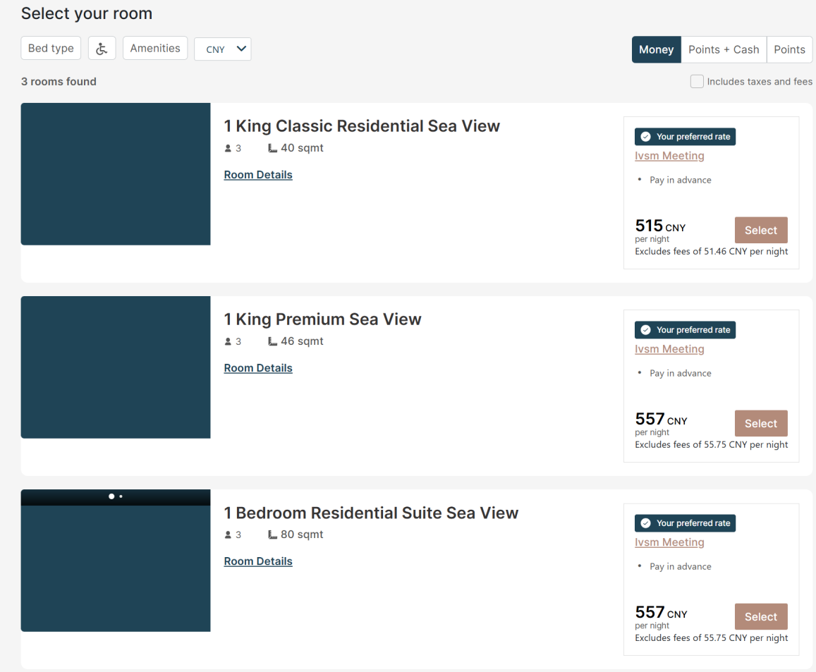

- Complete your reservation and pay online.
